# 

# Introduction: Defining the Context and Setting Objectives

**Problems and Challenges**

Address the challenge of navigating an extensive Regulatory Approval System for Building Work, comprising over thousands of rules and guidelines administered by more than hundreds of officers across several authorities in the CORENET X system. Utilize GenAI to streamline the process and alleviate major anxieties associated with the pre-consultations required to clear the requirements of technical agencies promptly..

**Objectives and Impact**

* Leverage Generative AI to efficiently process and comprehend the vast volume of regulatory and technical documents within the CORENET X system.
* Develop a solution that utilizes GenAI's capabilities to expedite pre-consultations, ensuring timely clearance of requirements from thel authorities.
* Address the acute shortage of experienced architects and BIM specialists by improving the efficiency of the design team significantly through AI-driven navigation and comprehension of regulatory complexities.
* Enhance the overall efficiency of the design team to meet the immediate and mid-term challenges associated with the CORENET X workflow, particularly in preparing the design model for the Design Gateway.

# Solution Framework: Crafting the Solution, Testing and Documentation

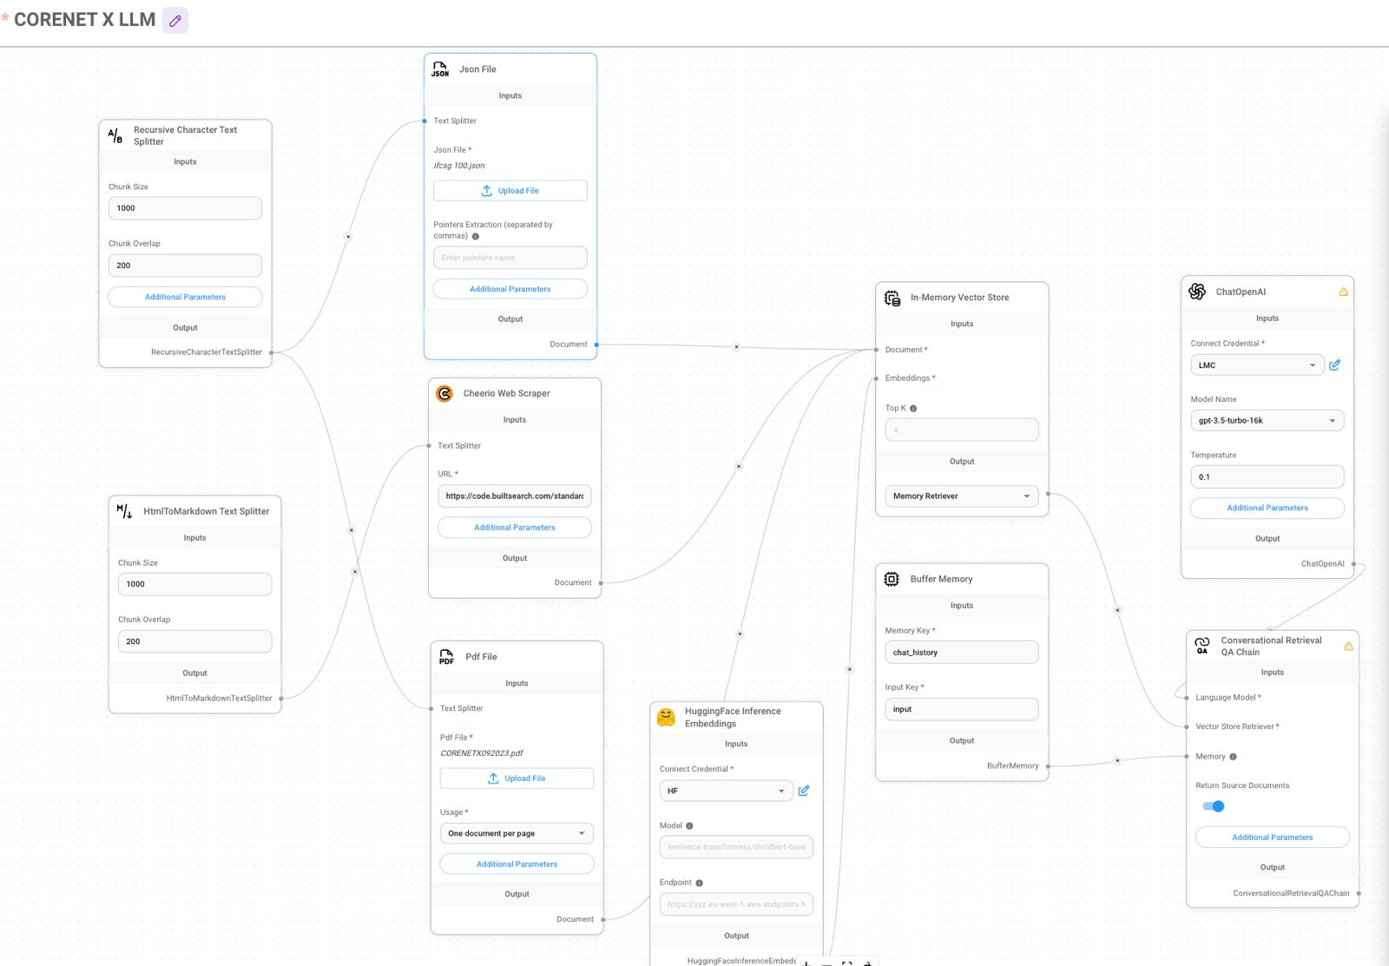

**Solutions and Tools:**

* Solution Components:
  + GenAI Model Knowledge Base and Fine Tuning:
  + Utilizes CORENET X rule and reference data parameters for RAG knowledge base creation.
* Fine-tunes the LLM Model to understand various compliance and submission requirements.
  + User Input Integration:
    - Allows customization of AI outputs to meet specific project needs.
* Generative Compliance Process:
  + - Employs AI to create a range of compliance requirements and responses.
* Retrieval-Augmented Generation (RAG):
  + - Incorporates RAG to enhance AI responses with external knowledge from an extensive regulatory and technical knowledge base.

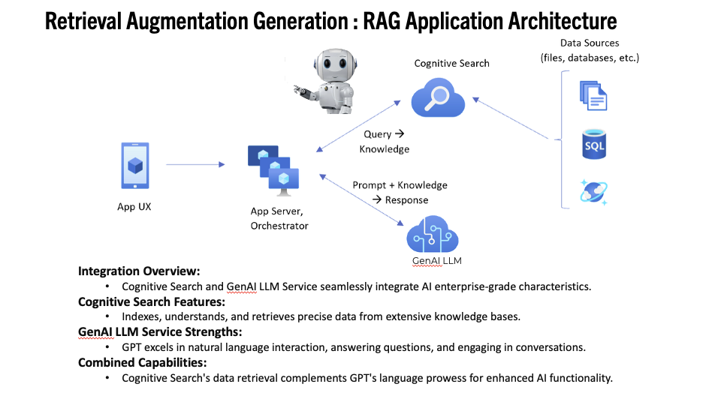

**Tools:**

* LangChain, LLamaIndex, Vector Database, LLM, and others.
* RAG: Implementation of Retrieval-Augmented Generation for improved context and factual information retrieval.

## **Limitations and Strategies:**

**Challenges:**

* AI model interpretation of CORENET X requirements.
* Complexity of measurable BIM (IFC-SG) parameters, CORENET X rules, and regulatory requirements.
* Cross-agencies workflow and non-compliance checking.
* New Challenge: Integration of external knowledge using RAG.

**Strategies:**

* Reiteration of the three components (AI Model Fine Tuning, Knowledge Augmentation, and Generative Process).
* Incorporation of RAG to address knowledge limitations and improve response accuracy.

**Tests and Measurements:**

**Testing with Colleagues:**

* Workflow to be tested on conceptual designs related to regulatory checks.
* RAG included in testing scenarios to evaluate its impact on response quality.

**Enhancements:**

* Reduced option engineering time, providing faster compliance and tender submission.
* New Enhancement: Evaluate the impact of RAG on response accuracy and speed.

**What Next:**

**Expansion:**

* Potential to expand AI capabilities with RAG to address more complex and diverse compliance requirements.
* Exploration of RAG's role in handling multi-objective submission approaches.

**User Feedback:**

* Robust user feedback mechanisms for continuous enhancement, now including RAG-related feedback.

**Advanced Techniques:**

* Exploring advanced AI techniques such as multi-modality model, mixture of experts (MOE), autonomous agents, deep learning, predictive modeling, and further integration of RAG for continuous innovation.

# 

# Documentation and Records:

* Comprehensive documentation and resources available on GitHub at GitHub.com/integrations-space/aiHackathon.
* Expanded documentation on the implementation and impact of RAG within the solution framework.

**Suggestions for Improvement:**

**Use Cases:**

* Elaborate on specific use cases or examples where the integration of RAG has been successfully applied in the context of the CORENETX workflow.

**Challenges during Testing:**

* Include any specific challenges faced during testing, particularly related to the introduction of RAG, and how they were addressed.

**GitHub Repository Details:**

* Provide more details on the GitHub repository, including the structure of documentation and specific resources related to the RAG implementation.